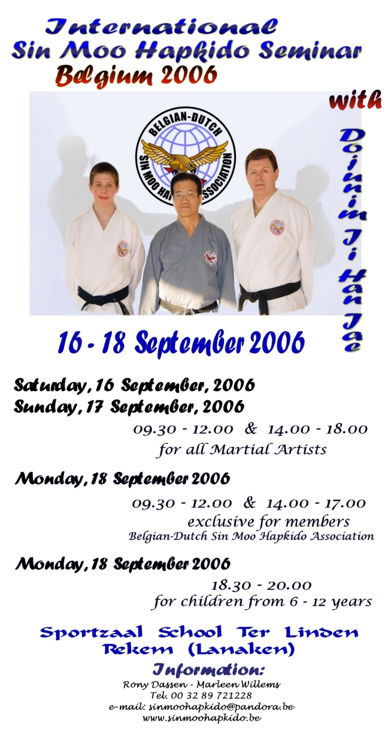



Seminar - details:
Organization: | The seminar is organized by the Belgian – Dutch Sin Moo Hapkido Association in cooperation with the World Sin Moo Hapkido Association  President: Rony Dassen, Schoolstraat 29, 3621 Rekem, Belgium
Location: | Sports hall Basisschool Ter Linden, 3621 Rekem (Lanaken)  entry in front of the KBC Bank, Populierenlaan in Rekem, Belgium.
Schedule: | Saturday 16 September 2006  and  Sunday 17 September 2006 | Sin Moo Hapkido training  for all Martial Artists
 | Saturday 16 September 2006  and  Sunday 17 September 2006 | 09.30 - 12.00  14.00 - 18.00 | 100 € - a day  200 € - for two days
 |  | Restricted number of participants! Max. 40
 | Monday 18 September 2006 | Black Belt training  only for members of the Belgian-Dutch Sin Moo Hapkido Assn.
 |  | 09.30 - 12.00  14.00 - 17.00 | 100 € - a day  200 € for 3 days
 |  | Restricted number of participants! Max. 20
 | Monday 18 September 2006 | Sin Moo Hapkido training  for kids from 6 – 12 years
 |  | 18.30 – 20.00 | 15 €
 |  | Restricted number of participants! Max. 30
Reservation: | Send the reservation document (completely filled in!) to us by mail or e-mail.
Make a money order to this bank account 850-8140847-23
to beneficiary: Hapkido Chung Do Kwan, Schoolstraat 29, 3621 Rekem, mentioning the day(s) you will participate.
Restricted number of participants!
How to reach us? | Coming from the direction Brussels – Antwerps – Netherlands – Germany:  You take the highway (motorway) E314 Brussels – Aachen, exit 34 Maasmechelen/Lanaken. Follow the N78 in the direction Lanaken for +/- 3 km.  After the roundabout, you continue in the direction Lanaken. At the first traffic lights, turn to the left, the Populierenlaan.  Before the speed ramp, you will see at your left a school building (white low-rise buildings) in front of the KBC-Bank. The dojang is in the first school building.  Coming from Liège or Maastricht :  Follow the direction Lanaken – Maasmechelen – Maaseik (N78)  In Rekem you will pass a small shopping center (Aldi…) at your right. Than, at the 3° traffic lights, you turn to the right, the Populierenlaan.  Before the speed ramp, you will see at your left a school building (white low-rise buildings) in front of the KBC-Bank. The dojang is in the first school building.  You can plan your route by this link:  http://www.viamichelin.com/viamichelin/gbr/dyn/controller/HomePageCom  or www.mappy.be
Registration Form:
Please send this reservation filled in back to us!

Name:
Birthday:
Nationality:
Mailing Address:

Country:
Phone number:
E-Mail:
Style:
Rank:

I Want to book for:

0 Saturday 16 September 2006, Sin Moo Hapkido Seminar for all martial artists
0 Sunday 17 September 2006, Sin Moo Hapkido Seminar for all martial artists
0 Monday 18 September 2006, Black Belt training for members of the Belgian-Dutch Sin Moo Hapkido Assn.
0 Monday 18 September 2006, Sin Moo Hapkido training for children from 6 – 12 years.

0 I make a money order of € on the bank account 850-8140847-23
iban: be92B 8508 1408 4723
Swiftcode: bic spaabe 22
to beneficiary Hapkido Chung Do Kwan, Schoolstraat 29, 3621 Rekem

Do not forget to mention your name and the dates on which you will follow the seminar!

- I wish to take lunch with the group (in Lunchroom – free choice of dish – Individual payment )

- I wish to participate at the diner with dojunim Ji, Han-Jae on sunday evening, € 30, soft drinks included. Address: Wok City, Maaseikersteenweg 209, 3620 Lanaken

!!! No photographing or video recording allowed during the seminar !!!
In consideration of being permitted to either observe or participate in the Sin Moo Hapkido Seminar, I declare that I am mentally fit and have engaged in the proper training to participate in or observe the Sin Moo Hapkido Seminar. If allowed to participate in or observe this seminar, I will abide by the rules used by Do Ju Nim Han-Jae Ji, Mr. Rony Dassen, the World Sin Moo Hapkido Assn., the Belgian-Dutch Sin Moo Hapkido Assn. and any additional instructors of this event. I will also follow any instructions given by the aforementioned instructors or institutions. I also understand that if I or anyone involved directly or indirectly with me shows disrespect to any of the instructors or fails to follow directions/instructions issued by any of the instructors or institutions, I may be evicted from the seminar without refund of monies paid to participate or observe. I/we hereby waive any compensation whatsoever, for any pictures, films, movies, media coverage, etc. taken of me at this seminar, and may be used by the promoters and those designated by the promoters now and in the future. I/we the undersigned, for himself/herself, personal representatives, heirs, next of kin acknowledges and agrees to the terms listed below:
1. Hereby releases, waives, discharges and covenants not to sue Dojunim Ji Han-Jae, Mr. Rony Dassen, and/or the Belgian-Dutch Sin Moo Hapkido Assn., the World Sin Moo Hapkido Assn., other instructors, promoters, other participants, sponsors, advertisers, owners and leasers of the premises used and anyone directly or indirectly related to the event, now or in the future, all for the purpose herein referred to as “releases,” from liability to the undersigned, for any and all damages, and any claims or demands therefore on account of injury to the person or property resulting in death of the undersigned, whether caused by the negligence of the releases or otherwise while the undersigned in participating in, observing and/or for any purpose participating in the event;
2. Each of the undersigned expressly acknowledges and agrees that the activities at the event are dangerous and involve risk of serious injury and/or
death and/or property damage. Each of the undersigned further expressly agrees that the foregoing release, waiver and indemnity agreement is extended to be as broad and inclusive as is permitted by the law of the province or state in which the event is conducted and that if any portion thereof is held invalid, it is agreed that the balance shall not withstanding continue in full legal force and effect.

For agreement,

Signature: __________________________________________ Date: _____________________

If you should need a residence for overnight staying, we can help you to find a room!

Or take a look at:

www.lanaken.com/ chose Horeca

www.lanaken.be chose Toerisme – VVV – Overnachtingen in Lanaken

www.limburg.be/toerismelimburg/logies.html

www.vvvmaastricht.nl/Hotels/index.php3?lang=en

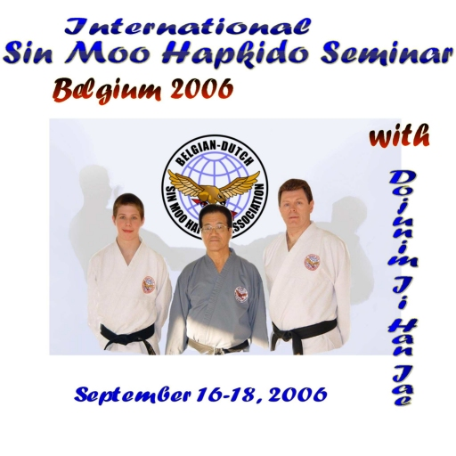

For all information:

Rony Dassen (President) – Marleen Willems (Secretary)
Belgian – Dutch Sin Moo Hapkido Association
Schoolstraat 29
3621 Rekem (Belgium)
Tel. / Fax. 00 32 89 721228
sinmoohapkido@pandora.be
www.sinmoohapkido.be

